**Excel Homework: Kickstart My Chart**

Drafted by: Mani Danesh Pajouh, Sep 2020.

1. **Given the provided data, what are three conclusions we can draw about Kickstarter campaigns?**

* **Camping Success/ Failure**

The following graph gives information about the state of campaigns per category. This bar chart shows the campaign on Theater, music, and Film& video has the most successful number and success ration compete with the other areas. (check the pie chart).

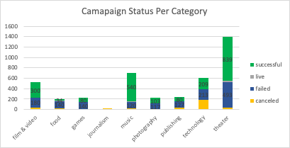

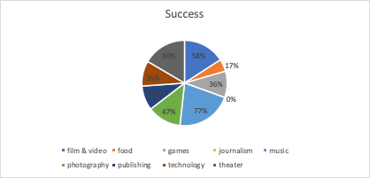

**Campaign Status, Jan – Dec:**

The following graph shows information about the campaign status trend between Jan till Dec. this graph contains the accumulative data per month from 2009 till 2017.

As the graph states, the number or successful campaign increased slightly in March and April and peaked by May. From May, the campaign success rate steadily declined; there was a fall in the successful campaign between Nov and Dec.

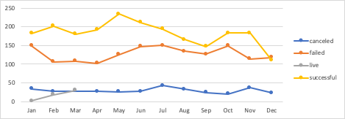

**Campaign Pledged Trend from 2009 – 2017**

The chart below gives information about the pledge amount (US $) based on the country between 2009 and 2017. According to the graph, the most amount belongs to the united states following by Great Britain.

According to the graph, the other countries began their campaigns from 2013. while they have lower levels of Pledged compare to US and GB, 2016 has the highest amount compare between 2009 and 2017.

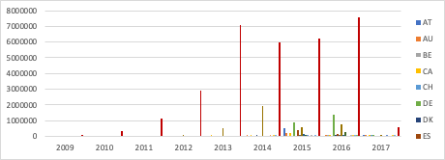

1. **What are some limitations of this dataset?**

* In the worksheet, the user does not have access to the exchange rates for converting the other currency to US$. For this activity, I used google for getting the latest exchange rates to US$ and apply the today( Sep 15, 2020) rates in the sheet.

**\* For having more accurate data, it would be good to have an average exchange** rate per month for every currency listed in the sheet.

* Far the states which are canceled/ failed, it would be good if the dataset contains the main reason for failure or cancelation.

1. **What are some other possible tables and/or graphs that we could create?**

* **Currency**: for having the better view of the monitory value, it would be good to have a same monitory value e.g. US$ in our data set. Then we can have a clear comparison between the US$ amount per county/ category and subcategory.
* **Yearly Trend:** yearly trend of different state was missing in this document. Yearly trend can provide very valuable insight on number of campaigns, success/failure of the campaigns, countries which participates, etc.